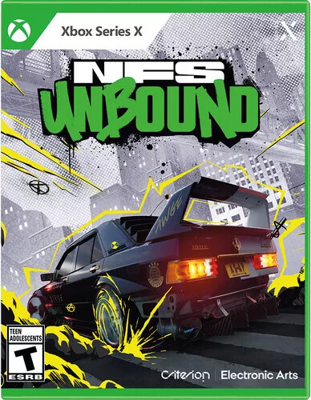

*Need for Speed Unbound:*

*1️.* ***Unique Stylized Graphics & Effects***

* *Combines* ***realistic car models*** *with* ***anime-inspired visual effects*** *like* ***graffiti-style boosts and smoke trails****.*

*2️.****Open-World Street Racing in Lakeshore City***

* *A* ***sprawling urban environment****, inspired by* ***Chicago****, filled with* ***races, challenges, and cop chases****.*

*3️.* ***Cop Chases & Heat System***

* *Police* ***adapt to player behavior****, with* ***more aggressive tactics at higher Heat levels****.*

*4️.* ***Deep Customization & Tuning***

* *Modify* ***engines, visuals, body kits, neon effects, and even driving styles*** *to fit your preferences.*

*5️.* ***Multiplayer & Weekly Events***

* *Online mode includes* ***rivalries, crew-based competitions, and limited-time races****.*